A Plan for Personal Financial Planning
LO1.4
Implement a plan for making personal financial and career decisions.
We all make hundreds of decisions each day. Most of these decisions are quite simple and have few consequences. However, some are complex and have long-term effects on our personal and financial situations, as shown here:

ACTION ITEM
Do you consider various types of risks when making personal financial decisions?
□ Yes □ No
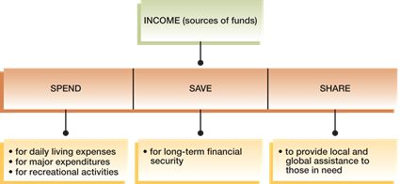
While everyone makes decisions, few people consider how to make better decisions. As Exhibit 1–4 shows, the financial planning process can be viewed as a six-step procedure that can be adapted to any life situation.

Exhibit 1–4 | The Financial Planning Process
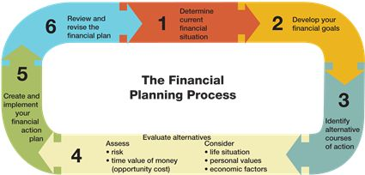

Page 16
STEP 1: Determine Your Current Financial Situation
In this first step, determine your current financial situation regarding income, savings, living expenses, and debts. Preparing a list of current asset and debt balances and amounts spent for various items gives you a foundation for financial planning activities. The personal financial statements discussed in Chapter 2 will provide the information needed in this phase of financial decision making.
EXAMPLE: Step 1, Determine Your Current Situation
Carla Elliot plans to complete her college degree in the next two years. She works two part-time jobs in an effort to pay her educational expenses. Currently, Carla has $700 in a savings account and existing debt that includes a $640 balance on her credit card and $2,300 in student loans. What additional information should Carla have available when planning her personal finances?
Example from Your Life
What actions have you taken to determine your current financial situation?
STEP 2: Develop Your Financial Goals
You should periodically analyze your financial values and goals. The purpose of this analysis is to differentiate your needs from your wants. Specific financial goals are vital to financial planning. Others can suggest financial goals for you; however, you must decide which goals to pursue. Your financial goals can range from spending all of your current income to developing an extensive savings and investment program for your future financial security.

did you know?
According to the National Endowment for Financial Education, 70 percent of major lottery winners end up with financial difficulties. These winners often squander the funds awarded them, while others overspend and many end up declaring bankruptcy. Having more money does not automatically mean making better financial planning choices.
Page 17
EXAMPLE: Step 2, Develop Financial Goals
Carla Elliot's main financial goals for the next two years are to complete her college degree and to maintain or reduce the amounts owed. What other goals might be appropriate for Carla?
Example from Your Life
Describe some short-term or long-term goals that might be appropriate for your life situation.
STEP 3: Identify Alternative Courses of Action
Developing alternatives is crucial when making decisions. Although many factors will influence the available alternatives, possible courses of action usually fall into these categories:
- Continue the same course of action. For example, you may determine that the amount you have saved each month is still appropriate.
- Expand the current situation. You may choose to save a larger amount each month.
- Change the current situation. You may decide to use a money market account instead of a regular savings account.
- Take a new course of action. You may decide to use your monthly saving budget to pay off credit card debts.
Not all of these categories will apply to every decision; however, they do represent possible courses of action. For example, if you want to stop working full-time to go to school, you must generate several alternatives under the category “Take a new course of action.” Creativity in decision making is vital to effective choices. Considering all of the possible alternatives will help you make more effective and satisfying decisions. For instance, most people believe they must own a car to get to work or school. However, they should consider other alternatives such as public transportation, carpooling, renting a car, shared ownership of a car, or a company car.
Remember, when you decide not to take action, you elect to “do nothing,” which can be a dangerous alternative.
EXAMPLE: Step 3, Identify Alternatives
To achieve her goals, Carla Elliot has several options available. She could reduce her spending, seek a higher-paying part-time job, or use her savings to pay off some of her debt. What additional alternatives might she consider?
Example from Your Life
List various alternatives for achieving the financial goals you identified in the previous step.
STEP 4: Evaluate Your Alternatives
You need to evaluate possible courses of action, taking into consideration your life situation, personal values, and current economic conditions. How will the ages of dependents affect your saving goals? How do you like to spend leisure time? How will changes in interest rates affect your financial situation?
Page 18
CONSEQUENCES OF CHOICES Every decision closes off alternatives. For example, a decision to invest in stock may mean you cannot take a vacation. A decision to go to school full-time may mean you cannot work full-time. Opportunity cost is what you give up by making a choice. These trade-offs cannot always be measured in dollars. However, the resources you give up (money or time) have a value that is lost.

did you know?
Nearly one billion people around the world live on $1 or less a day. Various organizations provide these people with basic need items and future opportunities. Bright Hope International assists the extreme poor by providing food, clothing, shelter, health care, education, orphan support, microloans, job training, and spiritual guidance. You can help to provide assistance to the extreme poor at www.brighthope.org.
EVALUATING RISK Uncertainty is also a part of every decision. Selecting a college major and choosing a career field involve risk. What if you don't like working in this field or cannot obtain employment in it? Other decisions involve a very low degree of risk, such as putting money in an insured savings account or purchasing items that cost only a few dollars. Your chances of losing something of great value are low in these situations.
In many financial decisions, identifying and evaluating risk are difficult. Common risks to consider include:
- Inflation risk, due to rising or falling (deflation) prices that cause changes in buying power.
- Interest rate risk, resulting from changes in the cost of money, which can affect your costs (when you borrow) and benefits (when you save or invest).
- Income risk may result from loss of a job or encountering illness.
- Personal risk involves tangible and intangible factors that create a less than desirable situation, such as health or safety concerns.
- Liquidity risk occurs when savings and investments that have potential for higher earnings are difficult to convert to cash or to sell without significant loss in value.
The best way to consider risk is to gather information based on your experience and the experiences of others and to use financial planning

